REF: UN/GEN.163/SC/mh 11 July 2016

TO:
ALL EXECUTIVE COUNCIL MEMBERS AND TUR’S

NEW E-MAIL ADDRESS

It is of utmost importance to the leadership of the United National Transport Union (UNTU) that our members are satisfied and well informed. For your convenience UNTU has created a new e-mail address where you can send any enquiries, questions or complaints so that the Union’s newly appointed Media and Liaison Officer, Sonja Carstens, can attend to them and ensure that you get a speedy response. This e-mail address is enquiries@untu.co.za.

All other services such as membership applications, applications for discretionary fund, death benefit and maternity claims will be dealt with by our current e-mail address headoffice@untu.co.za.

UNTU will continue to strive to add services/benefits for you, our loyal members to enjoy.

UNTU Greetings.

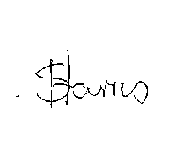
GENERAL SECRETARY

