Ref: CL/GEN.162/SH/mh 2016-07-05

TO:

ALL EXECUTIVE COUNCIL MEMBERS AND TUR’S

FACEBOOK & TWITTER

Please note that Sonja Carstens our newly appointed Media and Liaison Officer has created a UNTU Facebook page and a Twitter account for members to follow UNTU news.

This is part of the strategy to ensure members remain up dated with what is happening within UNTU.

We trust members will find these new service additions useful and utilise such.

 - United National Transport Union

 - UNTU@HeadofficeUntu

UNTU Greetings.

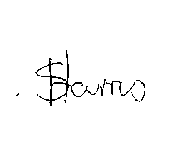

GENERAL SECRETARY

